ABHIVRIDDHI INFOTECH

Chapter 1: COMPANY INTRODUCTION

COMPANY PROFILE
Abhivriddhi Infotech is a leading IT solutions and service company established with a specific mission of providing comprehensive, top of the line solutions. Since its inception, Abhivriddhi Infotech has emerged as a key player in Ecommerce solution providers, Website Design and Development Abhivriddhi Infotech brings together the best Technology and Domain expertise in online solutions space to offer a full spectrum of services ranging from Implementation, Business Consulting, Maintenance and Managed Operations.
Abhivriddhi Infotech is a cutting-edge retail technology company that provides you all the tools to build your e-commerce business. Whether you are a conventional retailer intending to build your omni-channel business or an online-only retailer intending to build your e-commerce business, we have a suite of products that will quickly and easily empower you to achieve your goals.
The salient features of their internship program are:
- They have really good trainers who are well aware of the concepts and the various software that are being taught.
- They have hands on training for the concepts being taught and give appropriate assignments to further understand the concepts clearly.
- We are given real time use cases to solve and will be evaluated by the senior members in company We receive valuable feedback and suggestions for our work.
- All the support needed to learn the technology thoroughly is provided by the company.
- Sessions on how to interact with the client and other team members were also conducted which gave an idea of the shift from campus to corporates.

Mission of the company:
Abhivriddhi Infotech is dedicated to providing efficient and long-term software solutions for your business to increase your performance and competence in the industry.

Vision of the company:
To become a prime name in the business of software development in providing excellent and lasting services that help promote growth and facilitate the progress of a business through modern technology.

Services provided:
- Website Development: Customized website development using cutting-edge technologies.
- Digital Marketing: We provide digital marketing for your products through Search engine optimization, Content marketing, social media marketing, Email marketing.
- Software Training: Our training programs cover a wide spectrum of topics, ranging from fundamental programming languages to advanced frameworks and tools.
- Website Management: We are the architects, caretakers, and innovators behind the scenes, ensuring that your website is a seamless and engaging experience for visitors.
- Internship Opportunities: At Abhivriddhi, we believe in nurturing talent. Our internship program is designed to offer hands-on experience, mentorship, and a supportive environment for budding developers to sharpen their skills and contribute to real-world projects.
- Mobile App Development: Mobile application development for both Android and iOS operating systems, customized to client’s needs.

Objective of internship
The main objective of this internship is to provide hands-on experience in developing a website using HTML & CSS and Spring Framework along with SQL. As an intern I had been given the opportunity to learn and apply web development technologies, including HTML & CSS and Spring Framework along with SQL, while gaining proficiency in front-end and back-end development. The internship also focused on developing problem-solving skills through debugging, trouble shooting, and optimizing performance. Additionally, as an intern I was allowed to collaborate with a team, understand e-commerce concepts, and learn agile development practices. By the end of the internship, I will have a tangible portfolio project and a deeper understanding of web development, which can be valuable for their future career in the field of web development.

Internship Process details
The internship began with our onboarding where the representative of the company addressed us and explained what is expected from us in the program going forward. Firstly, we underwent training where all the basic concepts of programming were revised for two weeks. Secondly, I had been given a few sample projects to analyze which had features and implementations of HTML & CSS. I received mentorship and training from experienced professionals in the company. This involved regular sessions, code reviews, and feedback sessions to improve their skills, learn new technologies, and overcome challenges during the project. The progress and performance were constantly being evaluated periodically, based on the project's milestones, objectives, and the organization's criteria Feedback was being provided, and adjustments or improvements was made as needed.

Chapter 2:

PROJECT DESCRIPTION

About the Project:

Description
HTML is used as a base in the development of single-page, mobile website developments with frameworks like Spring & SQL for Database Communication. Whereas HTML is only used for providing structure, we require additional language calls CSS for providing styling to the website and another language called JavaScript for providing functionality. All of these languages combined, are used to create a functional webpage or website. Additionally, frameworks and database are used in the back-end to store and retrieve the data.

Technologies and Tools used:

HTML: HyperText Markup Language
HyperText Markup Language or HTML is the standard markup language for documents designed to be displayed in a web browser. It defines the content and structure of web content. It is often assisted by technologies such as Cascading Style Sheets (CSS) and scripting languages such as JavaScript.
Web browsers receive HTML documents from a web server or from local storage and render the documents into multimedia web pages. HTML describes the structure of a web page semantically and originally included cues for its appearance.
HTML elements are the building blocks of HTML pages. With HTML constructs, images and other objects such as interactive forms may be embedded into the rendered page. HTML provides a means to create structured documents by denoting structural semantics for text such as headings, paragraphs, lists, links, quotes, and other items. HTML elements are delineated by tags, written using angle brackets. Tags such as <img> and <input> directly introduce content into the page. Other tags such as <p> and </p> surround and provide information about document text and may include sub-element tags. Browsers do not display the HTML tags but use them to interpret the content of the page.
HTML can embed programs written in a scripting language such as JavaScript, which affects the behavior and content of web pages. The inclusion of CSS defines the look and layout of content. The World Wide Web Consortium (W3C), former maintainer of the HTML and current maintainer of the CSS standards, has encouraged the use of CSS over explicit presentational HTML since 1997. A form of HTML, known as HTML5, is used to display video and audio, primarily using the <canvas> element, together with JavaScript.
Features of HTML
- It is easy to learn and easy to use.
- It is platform-independent.
- Images, videos, and audio can be added to a web page.
- Hypertext can be added to the text.
- It is a markup language.
HTML Page Structure
The basic structure of an HTML page is shown below. It contains the essential building-block elements (i.e. doctype declaration, HTML, head, title, and body elements) upon which all web pages are created.
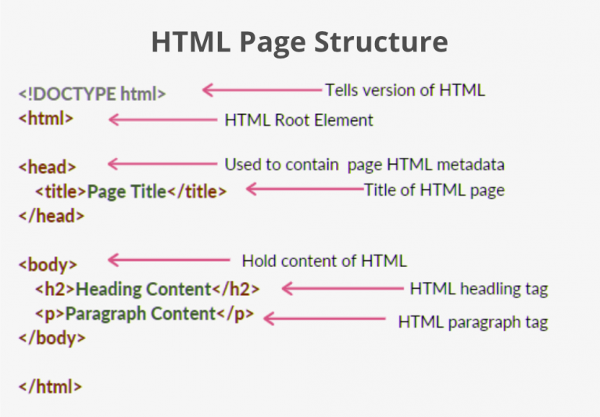
<!DOCTYPE html> – This is the document type declaration (not technically a tag). It declares a document as being an HTML document. The doctype declaration is not case-sensitive.
<html> – This is called the HTML root element. All other elements are contained within it.
<head> – The head tag contains the “behind the scenes” elements for a webpage. Elements within the head aren’t visible on the front end of a webpage. HTML elements used inside the <head> element include:
<style> – This HTML tag allows us to insert styling into our web pages and make them appealing to look at with the help of CSS.
<title> – The title is what is displayed on the top of your browser when you visit a website and contains the title of the webpage that you are viewing.
<base> – It specifies the base URL for all relative URL’s in a document.
<noscript> – Defines a section of HTML that is inserted when the scripting has been turned off in the user’s browser.
<script> – This tag is used to add functionality to the website with the help of JavaScript.
<meta> – This tag encloses the metadata of the website that must be loaded every time the website is visited. For eg:- the metadata charset allows you to use the standard UTF-8 encoding on your website. This in turn allows the users to view your webpage in the language of their choice. It is a self-closing tag.
<link> – The ‘link’ tag is used to tie together HTML, CSS, and JavaScript. It is self-closing.
<body> – The body tag is used to enclose all the visible content of a webpage. In other words, the body content is what the browser will show on the front end.
An HTML document can be created using an HTML text editor. Save the text file using the “.html” or “.htm” extension. Once saved as an HTML document, the file can be opened as a webpage in the browser.
Note: Basic/built-in text editors are Notepad (Windows) and TextEdit (MacOS). Other advanced text editors include Sublime Text, Visual Studio Code, Froala, etc.
HTML Elements and Tags
HTML uses predefined tags and elements that tell the browser how to display the content. HTML elements include an opening tag, some content, and a closing tag.
Remember to include closing tags. If omitted, the browser applies the effect of the opening tag until the end of the page.
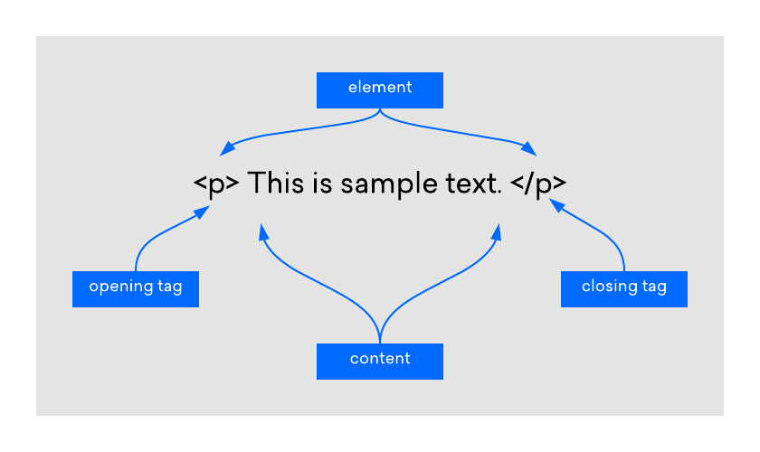

HTML Element
An HTML element is defined by a start tag, some content, and an end tag:
<tagname> Content goes here... </tagname>
The HTML element is everything from the start tag to the end tag:
<h1>My First Heading</h1>
<p>My first paragraph.</p>
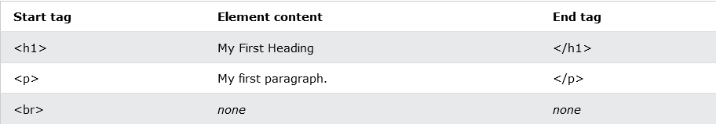

Web Browsers
The purpose of a web browser (Chrome, Edge, Firefox, Safari) is to read HTML documents and display them correctly.
A browser does not display the HTML tags, but uses them to determine how to display the document.

HTML History
Since the early days of the World Wide Web, there have been many versions of HTML:
Year | Version
1989 | Tim Berners-Lee invented www
1991 | Tim Berners-Lee invented HTML
1993 | Dave Raggett drafted HTML+
1995 | HTML Working Group defined HTML 2.0
1997 | W3C Recommendation: HTML 3.2
1999 | W3C Recommendation: HTML 4.01
2000 | W3C Recommendation: XHTML 1.0
2008 | WHATWG HTML5 First Public Draft
2012 | WHATWG HTML5 Living Standard
2014 | W3C Recommendation: HTML5
2016 | W3C Candidate Recommendation: HTML 5.1
2017 | W3C Recommendation: HTML5.1 2nd Edition
2017 | W3C Recommendation: HTML5.2

CSS: Cascading Style Sheets
Cascading Style Sheets (CSS) is a stylesheet language used to describe the presentation of a document written in HTML or XML (including XML dialects such as SVG, MathML or XHTML). CSS describes how elements should be rendered on screen, on paper, in speech, or on other media.
CSS is among the core languages of the open web and is standardized across Web browsers according to W3C specifications. Previously, the development of various parts of CSS specification was done synchronously, which allowed the versioning of the latest recommendations. You might have heard about CSS1, CSS2.1, or even CSS3. There will never be a CSS3 or a CSS4; rather, everything is now CSS without a version number.
After CSS 2.1, the scope of the specification increased significantly and the progress on different CSS modules started to differ so much, that it became more effective to develop and release recommendations separately per module. Instead of versioning the CSS specification, W3C now periodically takes a snapshot of the latest stable state of the CSS specification and individual modules progress. CSS modules now have version numbers, or levels, such as CSS Color Module Level 5.
    - SQL: Structured Query Language
Structured Query Language (SQL) is a domain-specific language used to manage data, especially in a relational database management system (RDBMS). It is particularly useful in handling structured data, i.e., data incorporating relations among entities and variables.
Introduced in the 1970s, SQL offered two main advantages over older read–write APIs such as ISAM or VSAM. Firstly, it introduced the concept of accessing many records with one single command. Secondly, it eliminates the need to specify how to reach a record, i.e., with or without an index.
Originally based upon relational algebra and tuple relational calculus, SQL consists of many types of statements, which may be informally classed as sublanguages, commonly: Data query Language (DQL), Data Definition Language (DDL), Data Control Language (DCL), and Data Manipulation Language (DML).
The scope of SQL includes data query, data manipulation (insert, update, and delete), data definition (schema creation and modification), and data access control. Although SQL is essentially a declarative language (4GL), it also includes procedural elements.
SQL was one of the first commercial languages to use Edgar F. Codd's relational model. The model was described in his influential 1970 paper, "A Relational Model of Data for Large Shared Data Banks". Despite not entirely adhering to the relational model as described by Codd, SQL became the most widely used database language.
SQL became a standard of the American National Standards Institute (ANSI) in 1986 and of the International Organization for Standardization (ISO) in 1987. Since then, the standard has been revised multiple times to include a larger set of features and incorporate common extensions. Despite the existence of standards, virtually no implementations in existence adhere to it fully, and most SQL code requires at least some changes before being ported to different database systems.
    - Spring Framework
Spring Framework (Spring) is an open-source software development framework that provides infrastructure support for building Java-based applications on any deployment platform.
Released in June 2003 by Rod Johnson under the Apache 2.0 license, Spring Framework is hosted by SourceForge.
One of the most popular Java Enterprise Edition (Java EE) frameworks, Spring helps developers create high-performing applications using plain old Java objects (POJOs) and servlet containers that speed up development. In addition to POJOs, Spring uses techniques like aspect-oriented programming (AOP) and dependency injection to simplify development and reduce application testing and maintenance costs. These framework qualities make Spring highly suitable for building reliable and scalable enterprise applications in Java EE 7, while simplifying the development process.
In contrast to Spring, classic frameworks and application programming interfaces (APIs), like Java Database Connectivity (JDBC), Java Server Pages and Java Servlet, can make building Java applications a more complex and time-consuming endeavour.
Apart from Spring and Java Server Faces, other popular Java frameworks include Maven, Hibernate and Struts.
    - Java (Programming Language)
Java is a high-level, class-based, object-oriented programming language that is designed to have as few implementation dependencies as possible. It is a general-purpose programming language intended to let programmers write once, run anywhere (WORA), meaning that compiled Java code can run on all platforms that support Java without the need to recompile. Java applications are typically compiled to bytecode that can run on any Java virtual machine (JVM) regardless of the underlying computer architecture. The syntax of Java is similar to C and C++, but has fewer low-level facilities than either of them. The Java runtime provides dynamic capabilities (such as reflection and runtime code modification) that are typically not available in traditional compiled languages.
Java gained popularity shortly after its release, and has been a very popular programming language since then. Java was the third most popular programming language in 2022 according to GitHub. Although still widely popular, there has been a gradual decline in use of Java in recent years with other languages using JVM gaining popularity.
Java was originally developed by James Gosling at Sun Microsystems. It was released in May 1995 as a core component of Sun's Java platform. The original and reference implementation Java compilers, virtual machines, and class libraries were originally released by Sun under proprietary licenses. As of May 2007, in compliance with the specifications of the Java Community Process, Sun had relicensed most of its Java technologies under the GPL-2.0-only license. Oracle offers its own HotSpot Java Virtual Machine; however, the official reference implementation is the OpenJDK JVM which is free open-source software and used by most developers and is the default JVM for almost all Linux distributions.
As of March 2024, Java 22 is the latest version. Java 8, 11, 17, and 21 are previous LTS versions still officially supported.
    - Visual Studio Code (VS Code)
It is a popular source code editor developed by Microsoft that is widely used by developers for various programming languages and frameworks, including web development. It provides a range of features designed to improve developer productivity, such as code highlighting, code completion, debugging, and integrated version control. VS Code also has a large extension marketplace with a wide range of extensions for different programming languages, frameworks, and tools. For web development, VS Code is often used in combination with other technologies such as HTML, CSS, and JavaScript, as well as popular frameworks like ReactJS and Nodejs VS Code has built-in support for these languages and frameworks, providing developers with a range of useful features and tools.
One of the key benefits of using VS Code is its extensibility Developers can install extensions to customize and enhance their development environment to suit their specific needs. For example, there are extensions available for auto-completion of code, syntax highlighting, and debugging tools.

OJT-1
Intern Role: During OJT-1, Intern played the role of frontend web designer and developer as well as involved in server-side coding.

Intern Responsibilities:
- Fulfilling tasks set out by supervisors from project team.
- Learning the technologies from the mentors in the company.
- Testing the code changes and fixing the bugs if any found during the development work.
- Testing their changes when the code is deployed in test environment.
During this period, we found that Intern is
- Eager to learn and work with various technologies in the company.
- Excellent verbal and written communication skills.
- Proficiency in Microsoft Office.
- Ability to multitask.
- Cope well under pressure.
Intern’s Duties
- During OJT-1 (On-the-Job Training 1), the intern's role and responsibilities are designed to provide them with practical experience and exposure to the real-world working environment. The intern is expected to contribute to the organization while also learning and developing their skills.
- Learning and Observing: Initially, the intern will spend time observing and familiarizing themselves with the organization's operations, processes, and work culture. They will be introduced to their team members, supervisors, and mentors.
- Assisting Senior Staff: The intern will support senior staff members in their daily tasks and projects. This may include conducting research, gathering data, preparing reports, organizing documents, and performing administrative duties. By actively assisting the team, the intern gains hands-on experience and a deeper understanding of the organization's workflow.
- Skill Development: The internship provides an opportunity for the intern to apply their technical knowledge gained through academic studies. They may be assigned specific tasks related to their area of specialization, allowing them to further develop their skills and expertise. This could involve programming, data analysis, graphic design, marketing, engineering, or any other field relevant to the organization's operations.
- Collaborative Projects: During the internship, the intern may be involved in small-scale projects or assist in ongoing initiatives. They may work alongside other team members to complete assigned tasks or contribute to project deliverables. These projects allow the intern to apply their technical knowledge and work collaboratively within a professional team environment.
- Training and Mentoring: Throughout the internship, the intern may receive training sessions or workshops on various topics, including company policies, software tools, industry trends, and professional development. They may also have access to mentors or supervisors who guide and provide feedback to help them improve their skills and performance.
- Value Creation: The intern can create value for the organization by bringing fresh perspectives, innovative ideas, and up-to-date technical knowledge. They may propose improvements or optimizations in existing processes, contribute to the development of new solutions, or assist in the implementation of innovative projects. By actively participating and providing valuable input, the intern adds value to the organization's operations.
- Learning Outcomes and Evaluation: At the end of the OJT-1, the intern's progress and performance will be evaluated. This evaluation can be based on the completion of assigned tasks, feedback from supervisors and mentors, and the intern's ability to apply their technical knowledge effectively. The intern will also have the opportunity to reflect on their learning outcomes and identify areas for further growth
Overall, the intern's role and responsibilities during OJT-1 involve learning, observing, assisting senior staff, developing technical skills, participating in collaborative projects, creating value through their knowledge and ideas, and receiving guidance and evaluation from supervisors and mentors The internship serves as a bridge between academic knowledge and practical application, allowing the intern to gain valuable experience and contribute to the organization's success.

OJT – 2

Intern Role:
- During OJT-2, Intern acted as a frontend developer by working on webpage creation, using HTML for building the webpage & CSS for styling.
- They were involved in

Intern Responsibilities:
- Fulfilling tasks set out by supervisors from project team.
- Learning the technologies from the mentors in the company.
- Testing the code changes and fixing the bugs if any found during the development work.
- Testing their changes when the code is deployed in test environment.
During this period, we found that Intern is
- Eager to learn and work with various technologies in the company.
- Excellent verbal and written communication skills.
- Proficiency in Microsoft Office.
- Ability to multitask.
- Cope well under pressure.
Intern’s Duties
During OJT-2 (On-the-Job Training 2), the intern's role and responsibilities typically build upon the foundation established during OJT-1. The intern is expected to apply their technical knowledge and skills in a more independent and advanced manner.
- Project Management: As the intern progresses into OJT-2, they may be assigned more substantial projects to manage independently or as part of a team. These projects can be related to research, development, implementation, or improvement of systems, processes, or products. The intern will be responsible for project planning, execution, monitoring progress, and delivering results within specified timelines.
- Technical Expertise: The intern's technical knowledge gained through academic studies becomes crucial during OJT-2. They may be entrusted with tasks that require specialized skills, such as programming, design, engineering, or any other area relevant to the organization's operations. The intern will apply their expertise to solve complex problems, make informed decisions, and contribute to the organization's technical objectives.
- Collaboration and Communication: The intern will collaborate with team members, supervisors, and stakeholders on various projects. They will actively participate in meetings, discussions, and brainstorming sessions, contributing their technical insights and suggestions. Effective communication skills, both written and verbal, will be important for the intern to convey ideas, progress, and results clearly and professionally.
- Research and Development: The intern may be involved in research and development activities within their field of expertise. They may explore new technologies, conduct experiments, analyze data, and provide recommendations for innovative solutions or improvements. The intern's technical knowledge and analytical skills will be crucial in conducting thorough research and proposing effective strategies.
- Process Improvement: The intern can contribute to the organization by identifying opportunities for process improvement and efficiency They may analyze existing workflows, systems, or procedures, and propose modifications or automation to streamline operations. The intern's technical knowledge can be applied to optimize processes, reduce costs, enhance productivity, and improve overall performance.
- Mentorship and Leadership: As the intern gains experience and proficiency, they may have the opportunity to mentor or guide new interns or junior team members. They can share their technical knowledge, provide guidance, and assist in their professional development. This experience helps the intern develop leadership skills and contributes to the growth of the organization's talent pool.
- Value Creation: Through their technical knowledge and skills, the intern can create value for the organization in several ways. They can contribute to the development of new products or services, improve existing processes, solve complex problems, enhance data analysis capabilities, or introduce innovative approaches. By leveraging their expertise, the intern can bring fresh perspectives, creativity, and efficiency to the organization, ultimately contributing to its growth and success.
- Evaluation and Feedback: Throughout OJT-2, the intern's performance and progress will be evaluated based on their ability to complete assigned projects, meet objectives, and demonstrate technical competence. Feedback from supervisors, mentors, and stakeholders will help the intern refine their skills, identify areas for improvement, and further enhance their professional development.
Overall, during OJT-2, the intern's role involves project management, applying technical expertise, collaborating with the team, conducting research, contributing to process improvement, potentially taking on mentorship responsibilities, creating value through their knowledge, and receiving evaluation and feedback The internship provides an opportunity for the intern to demonstrate their capabilities, make meaningful contributions, and further develop their technical skills while bringing value to the organization's goals and objectives.

